Project 1: Video-special effects
Aayush Hitesh Sanghvi | Yogi Hetal Shah

MS in Robotics | Electrical and Computer Engineering
Introduction:
In our daily lives,digital images are being used all over the place, necessitating the widespread use of image filtering techniques. OpenCV, a widely used library for computer vision, emerges as a powerful tool for image filtering. This project explores the various filters and effects implemented on a video by using OpenCV library. Let's explore every filter/effect being implemented in this project
1. This task reads an image from the directory and displays it using OpenCV functions. The program allows the user to display the Blue, Red and Green channels of an image by entering ‘b’, ‘g’, ‘r’ keys respectively. Below image displays the original as well as the BGR representation of an image. An additional functionality where the greyscale version of the image is displayed by pressing the ‘y’ key. The program has used the NTSC formula to convert BGR to grayscale.
Y = 0.299*r + 0.587*g + 0.114*b

Fig 1.Original and BGR channel images Fig 2. Grayscale image
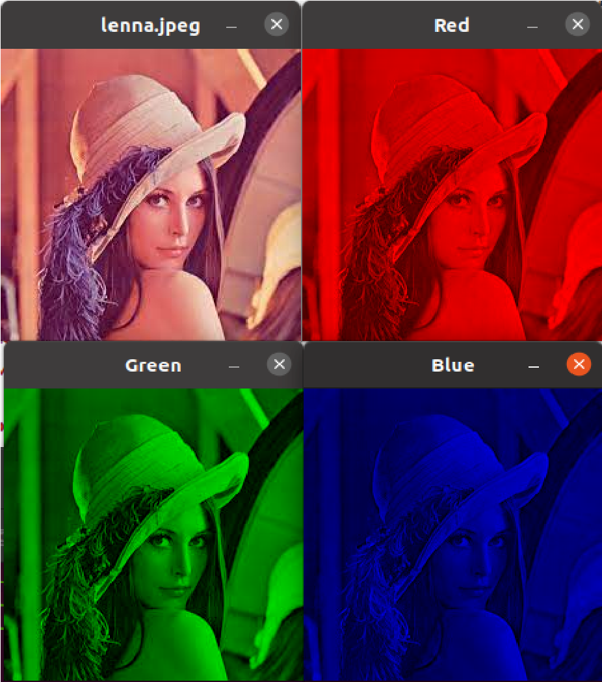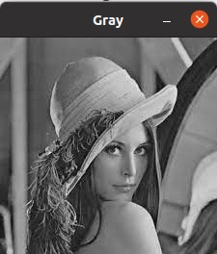
- This task displays a live video from the laptop camera as well as a video from the directory in a window. Below are screenshots of both the videos. Fig 3. Live Video
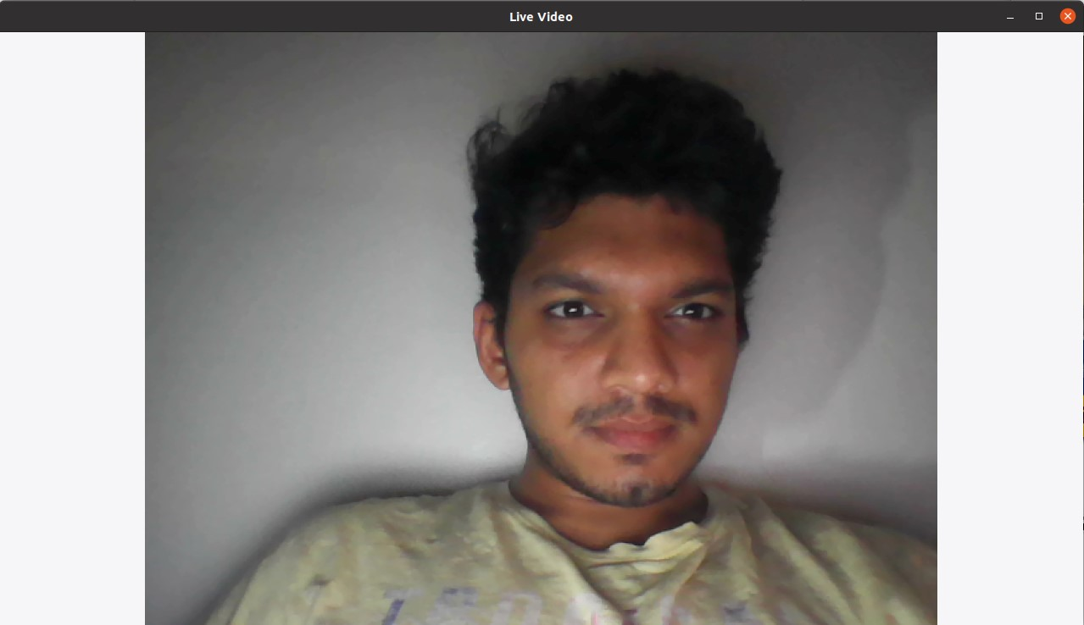
The code also displays a feature where, the live video and the video from directory being played quits if the user types in ‘q’. This feature was achieved by monitoring the key pressed event using the waitKey function of OpenCV.
- A grayscale version of the video is generated using OpenCV convert color function which passes three arguments, the input image, the output image and the color conversion code which in this case is COLOR_BGR2GRAY. This color conversion code uses the NTSC formula shown below to convert the BGR channel to grayscale. By multiplying different channel pixel values with specified weights, we can achieve grayscale version of the image.
Y = 0.299*r + 0.587*g + 0.114*b

Fig 4. Grayscale image Fig 5. Original Image
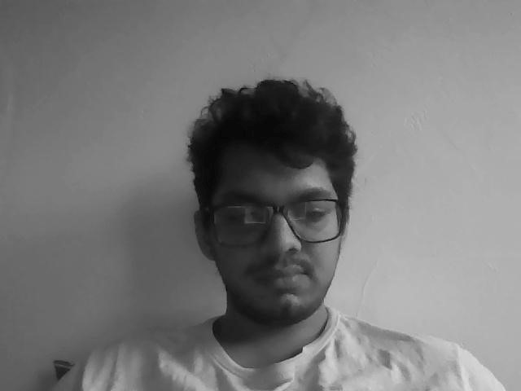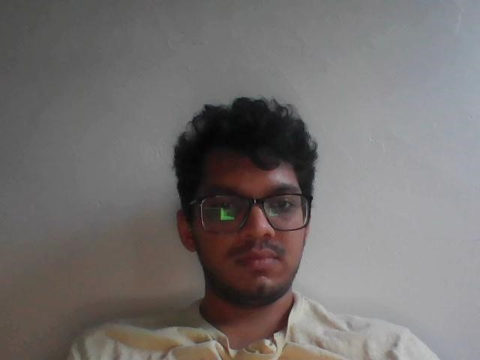
4. An alternative version of the grayscale is displayed below. To achieve this effect, 255 is subtracted from the red channel which would result in a 0 value for a pure red pixel in the original image thus resulting in a pure black color in grayscale image. Rest of the channels are assigned the same value thus resulting in a grayscale version of the image. The below two screenshots show the alternative grayscale and the grayscale image.

Fig 6. Alternative Grayscale image Fig 7. Grayscale image
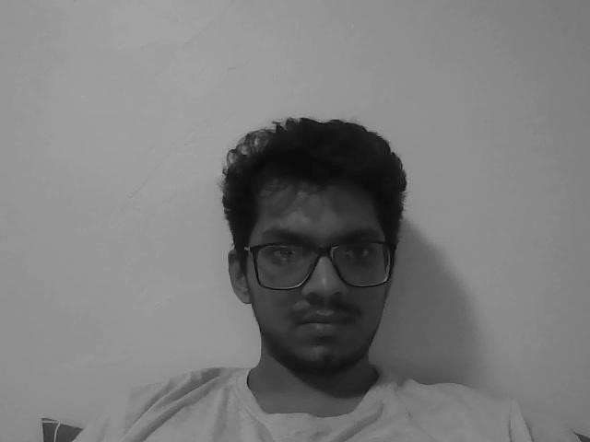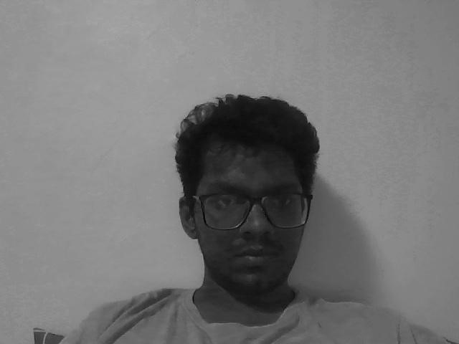
5. Sepia tone filter is implemented on the frames of the video. We performed some basic addition and multiplication of predefined coefficients with each pixel value in all 3 channels of the original image.
0.272, 0.534, 0.131- Blue coefficients; 0.349, 0.686, 0.168- Green coefficients;
0.393, 0.769, 0.189- Red coefficients
To achieve this effect, an empty image with the size of the original image has been defined. The program then uses the pointer method to iterate through each row and column. The pixel value of the original image for each channel is accessed, multiplied with the respective coefficient value mentioned above and accumulates the result. This value is stored in the respective channel of the output image thus resulting in a sepia tone.

Fig 8. Sepia tone
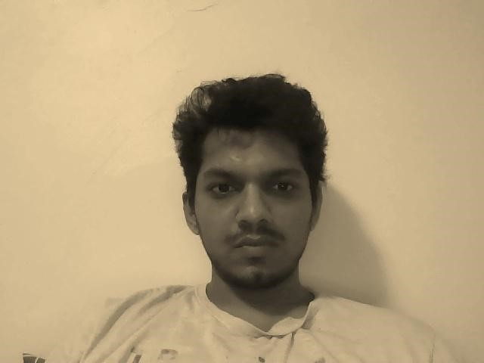
6. Blur image is generated by convoluting the pixels of each channel in the original image with a 5x5 gaussian matrix. Difference between blur frame and original frames can be depicted from the images below

Fig 9. Blur frame Fig 10.Original frame
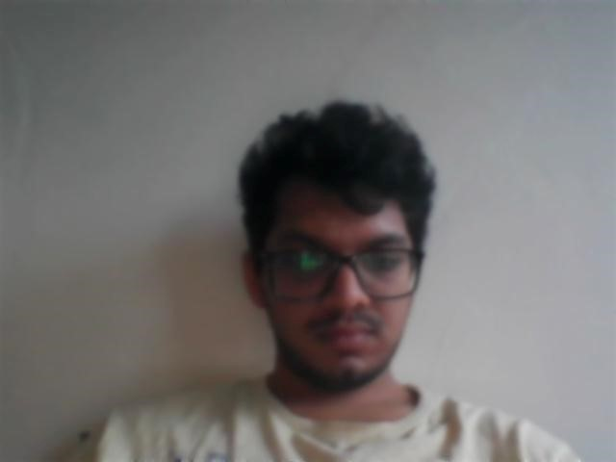
Two different methods were used to create a blurred effect. First method is the direct method using the “at” method to access the pixel values and convolute with the 5x5 gaussian matrix. Second method uses the “ptr” method which produces the same result as the first one. Execution time of both the functions has been calculated using the timeblur program and shown below.

Fig 11. Time frame of blur function execution
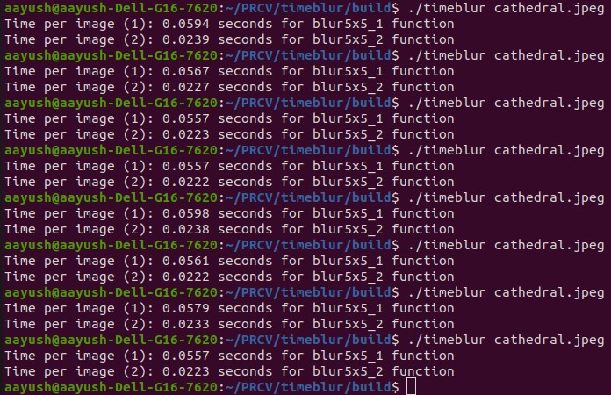
Blur5x5_1 represents the function using the at method and blur5x5_2 represents the function using the ptr method. If we look at the time taken by the code to execute these functions, we can see that blur5x5_2 requires less than half of the execution time taken by the blur5x5_1 function to produce the same output thus making blur5x5_2 more efficient and an optimized function.
7. Sobel X and Y images are generated by convoluting the pixel values with a 3x3 sobel filter. Sobel X output was achieved by convoluting the pixel values of image with 1x3 separable filter, Gx = [1 2 1]’ * [-1 0 1]. Similarly, Sobel Y was implemented by convoluting the pixel values with Gy = [1 0 -1]’*[1 2 1].

Fig 12. Sobel X Output Fig 13. Sobel Y Output
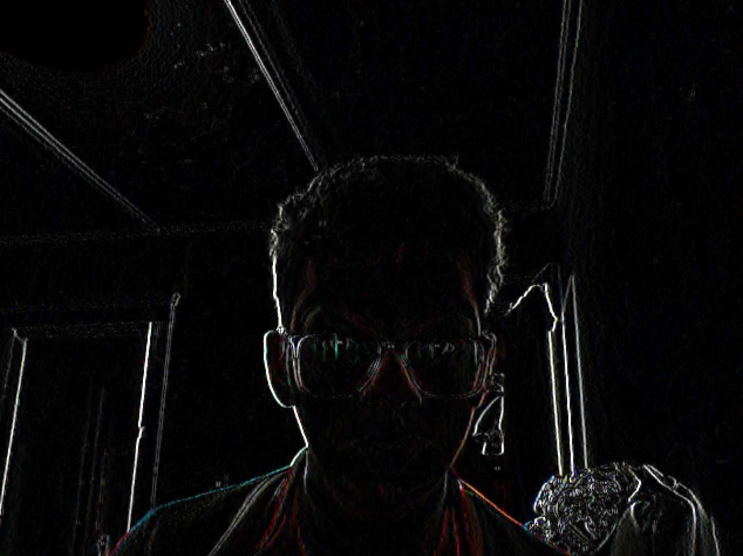
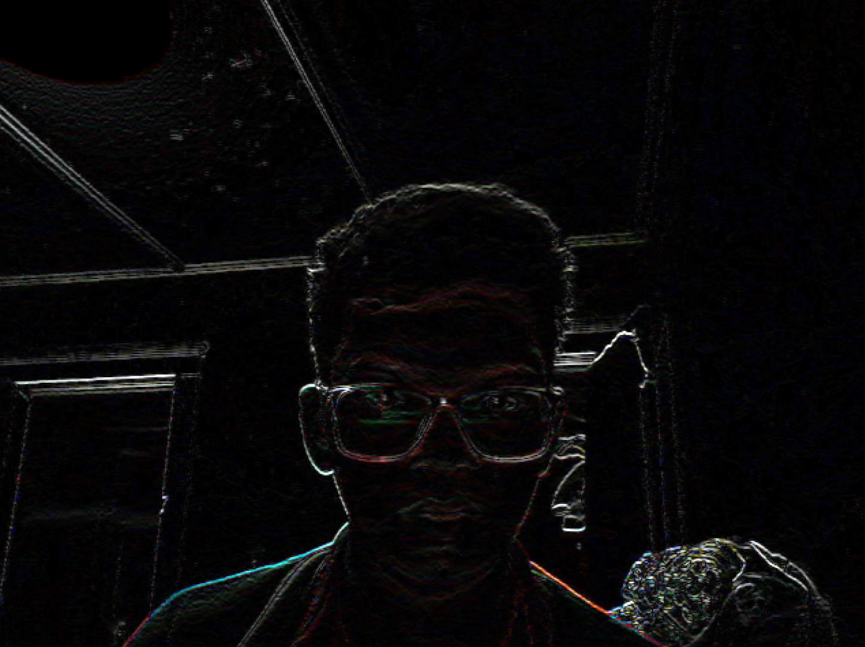

8. Gradient magnitude is generated using the Sobel X and Sobel Y images obtained earlier and the computing the euclidean distance formula for magnitude l = sqrt( sobel_x*sobel_x + sobel_y*sobel_y )

Fig 14. Gradient Magnitude Fig 15. Original Image
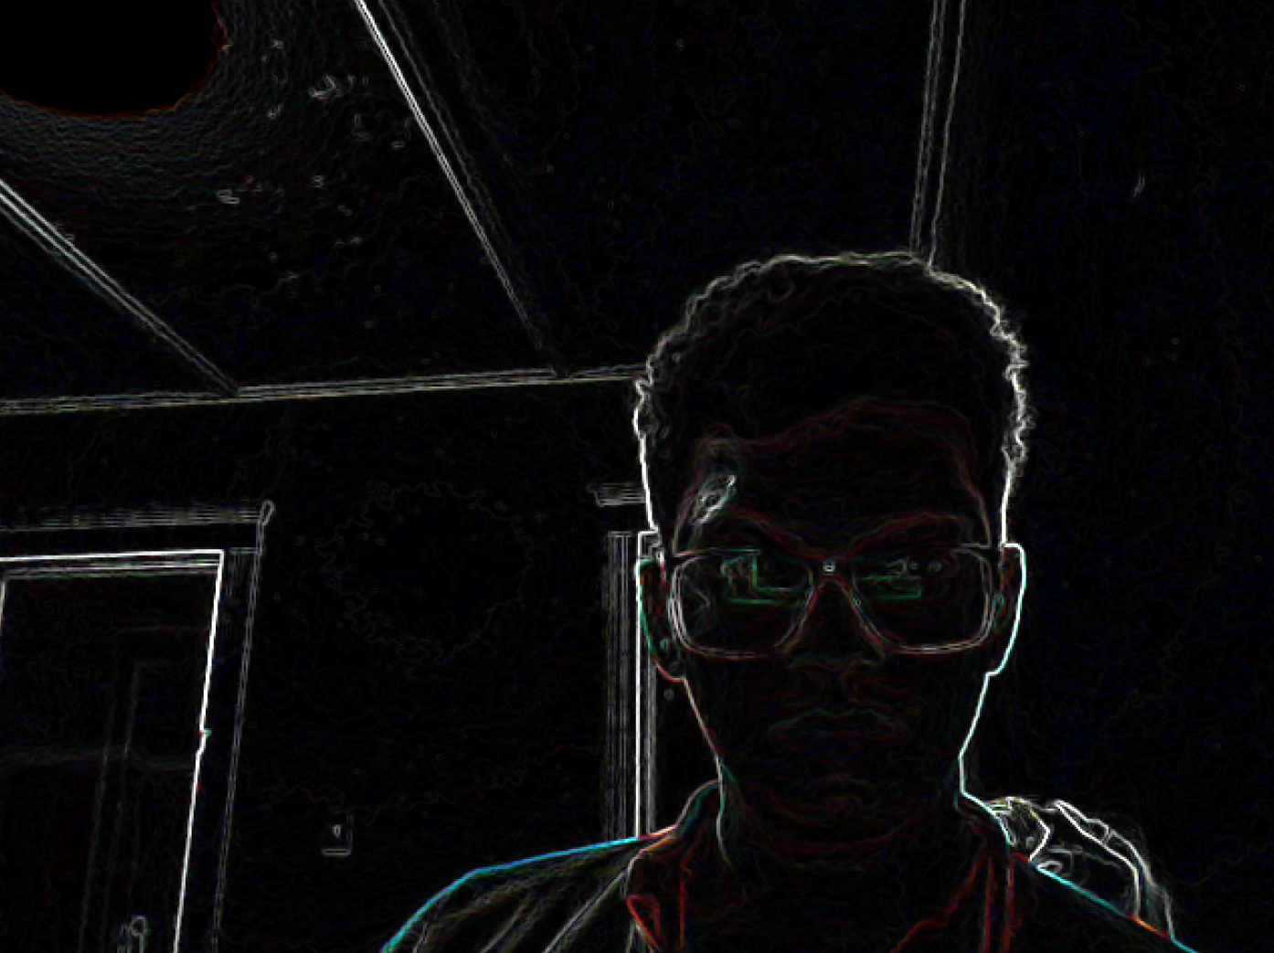
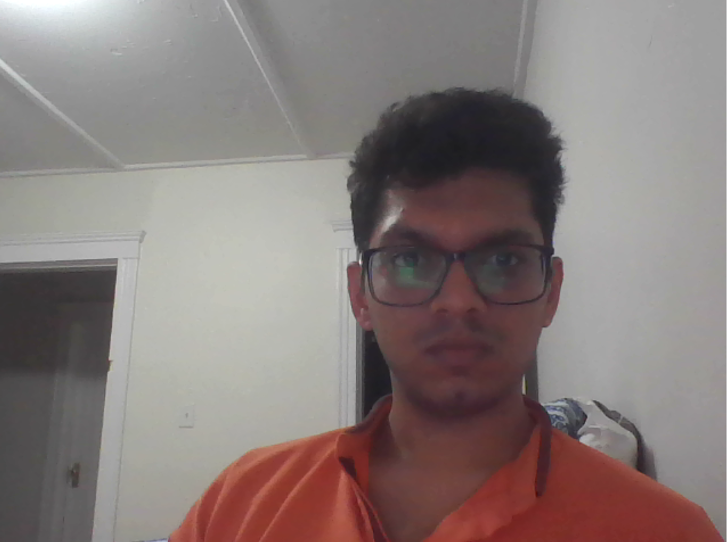

9. To obtain blur quantisation, the original image was first blurred using the function described in point 6. and then each color channel was quantized in 10 levels with a bucket size of b = 255/ 10 = 25.5. Subsequently, each color channel was divided by “b” and then the resulting image was multiplied by “b”.

Fig 16. Blur Quantized Image Fig 17. Original Image
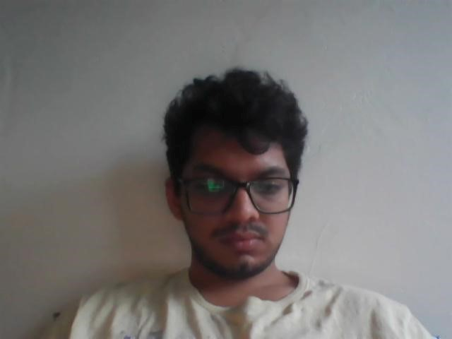
10. Face detection code was linked to the main function and this code uses a haarcascade XML file to detect faces in an image.

Fig 18. Detected Face in an Image
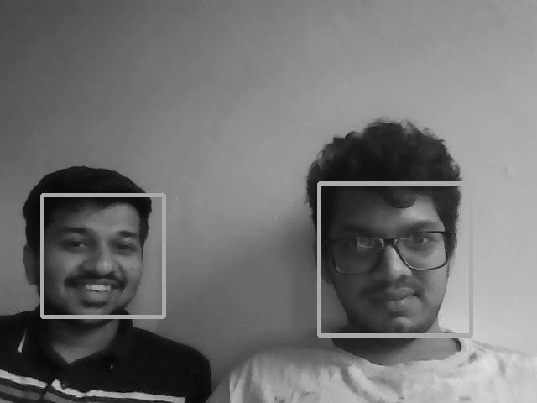
11. The image outside the faces is blurred by first detecting the faces and saving the rectangle vector which contains coordinates of the faces detected in an image. Further, the image is blurred using the function as described in point 6. The program then proceeds to iterate through the pixels corresponding to the coordinates of the rectangle. During this iteration, it assigns each pixel with the original pixel value. The difference between background and face can be depicted from the orange presented in the image.

Fig 19. Blur the image outside of the found faces
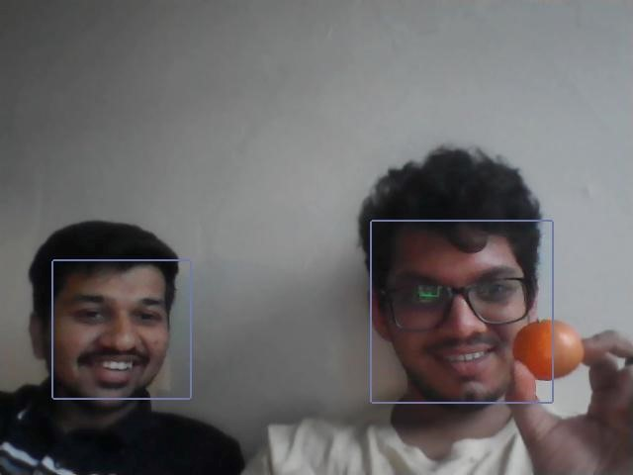
12. The face detected in the image is colorful while rest of the image is grayscale. This effect can be implemented by first detecting the faces using the function described above. The function also stores the coordinates of the rectangle that contains the face detected in a vector. The program then converts the image into a grayscale then proceeds to iterate through the pixels corresponding to the coordinates of the rectangle. During this iteration, it assigns each pixel with the original pixel value.

Fig 20. Make the face colorful, while the rest of the image is grayscale
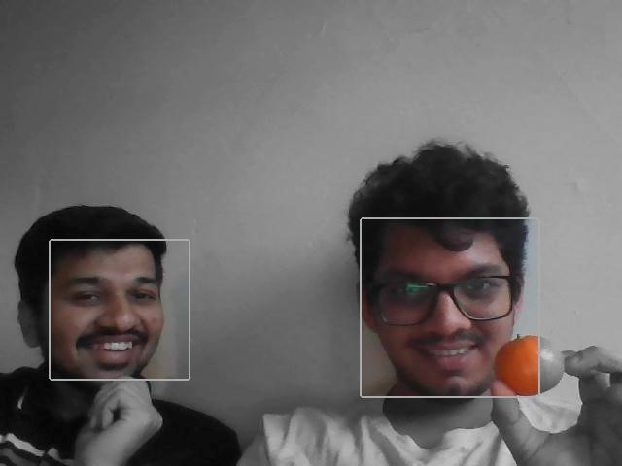
13. This effect places a halo right above the faces detected in the image. This can be achieved by first detecting the faces using the function described above. The function also stores the coordinates of the rectangle that contains the face detected in a vector. The program then creates a halo using the OpenCV ellipse function and uses the coordinates of the rectangle in the vector to place the halo right above the face in the image. The effect also places a small tilak on the forehead of the faces.

Fig 21. Put sparkles in a halo above the face
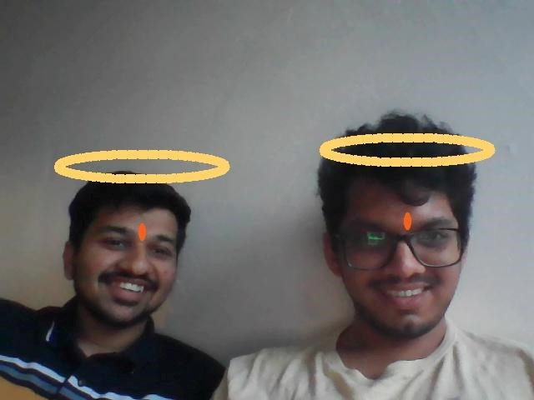
Extensions:
1. Sepia tone with vignetting effect: The filter first applies the sepia effect on the image. Further it creates a circle on the center of the image using inbuilt opencv function and implements a Gaussian blur outside the circle thus creating a vignetting effect.

Fig 22. Sepia filter with vignetting effect
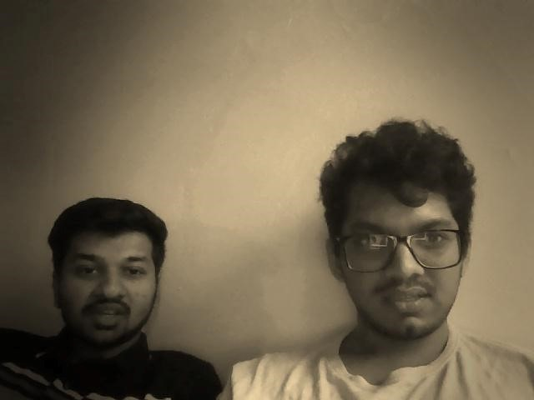
2. Cartoonization of the image is obtained by performing multiple image processing operations in a flow. The edges in the image are detected using the medianblur and adaptive thresholding of opencv in the grayscale image. After this the image is quantized to a level that reduces the sharpness of the image and followed by this the image undergoes bilateral filtering and some bitwise operations which gives us the cartoonized version of the image as shown below.

Fig 23. Cartoonization of image
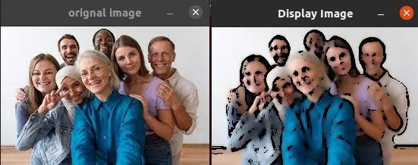

Reflection:
From this project, I understood the basics of OpenCV functions, how we can access each pixel of an image and modify the images using basic arithmatic operators. I got to learn about various filters and how we can modify the outputs of the filters by either changing the matrix values and creating various kinds of filters. We also learned how to faces are being detected and how we can create different filter specifically on the face by using haar cascade face detection features. Implementing various filters and face detection algorithm using C++ was a good experience.

Acknowledgements:
https://www.geeksforgeeks.org/python-grayscaling-of-images-using-opencv/
https://en.wikipedia.org/wiki/Sobel_operator
https://docs.opencv.org/3.4/d2/d2c/tutorial_sobel_derivatives.html
https://docs.opencv.org/3.4/d6/dcf/classcv_1_1Vec.html
https://docs.opencv.org/4.x/da/d54/group__imgproc__transform.html
https://dev.to/ethand91/creating-various-filters-with-opencvpython-3077
https://www.geeksforgeeks.org/opencv-c-program-face-detection/
https://www.objc.io/issues/21-camera-and-photos/face-recognition-with-opencv/

